**1.Create docker container**

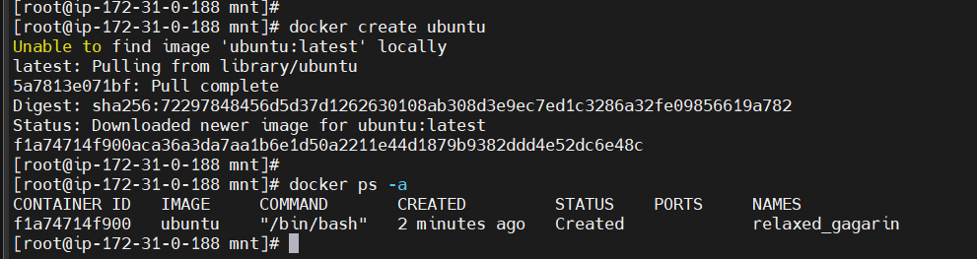

**2.Execute and create container**

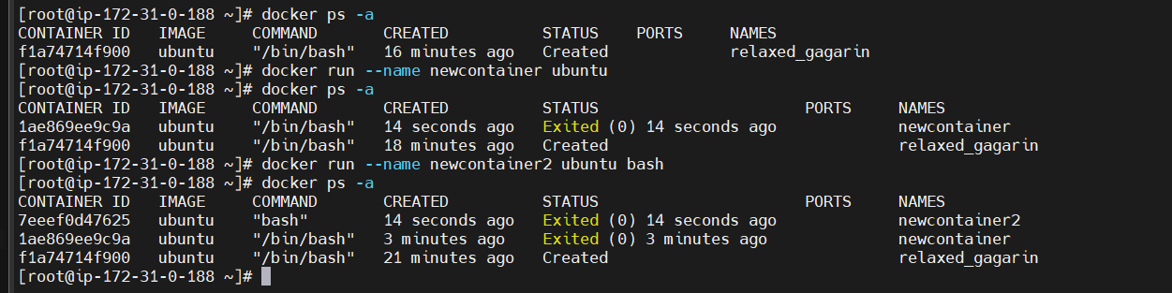

**3 start container**

